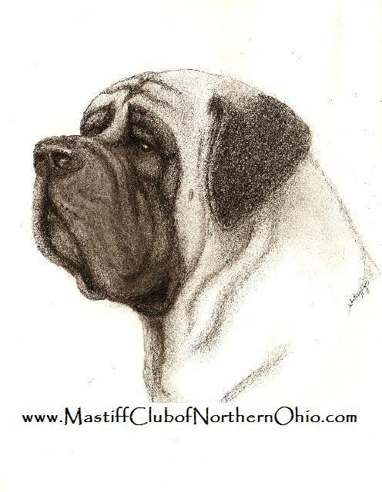

The Mastiff Club of Northern Ohio
was created in 2008 for Ohio and all surrounding area and is gradually spreading to include mastiff-lovers in many states and Canada.
It is a slowly developing club.....
starting as an excuse to gather at the dog shows and growing into a great little mastiff support group.
We are open to all ideas and suggestions to improve the website and the club itself.
Our members range from long-time breeders to first-time owners.

Please feel free to ask questions:

Mastiff Club of Northern Ohio NEW MEMBERSHIP APPLICATION

NAME:________________________________________________________

ADDRESS:____________________________________________________

CITY:________________________STATE:_____________ ZIP:__________

CELL PHONE:______________________

EMAIL:____________________________________________________________

KENNEL NAME/WEBSITE:________________________________________________

INTERESTS:___________________________________________________________

____JUNIOR APPLICATION (UNDER 18 YR) _____INDIVIDUAL_____COUPLE APPLICATION

SIGNATURES OF TWO (2) CURRENT MCONO MEMBERS:

______________________________________________________________
signature name date

______________________________________________________________
signature name date

NEW MEMBERSHIP DUES ARE AS FOLLOWS (7/1/18-6/30/19):
$15 INDIVIDUAL​​ / $20 COUPLE​ / $1 JUNIORS (UNDER 18)

IF APPLYING AFTER JANUARY 1ST, 2019 SINGLE AND FAMILY DUES WILL BE APPLIED TO THE FOLLOWING YEAR (2019/2020). IF PAYING BY CHECK PLEASE MAKE PAYABLE TO MCONO AND FORWARD COMPLETED APPLICATIONS AND MEMBERSHIP DUES TO:
MCONO TREASURER, 2453 Bradley Dr / Ashland, KY 41101

I AGREE TO ABIDE BY THE CODE OF ETHICS OF THE MCONO (available on our website.) AND THE RULES OF THE AMERICAN KENNEL CLUB.

_______________________________________________________________________________
SIGNED DATE

Please have each family member fill out their own application

Amount Enclosed___$______________ Check #______________

