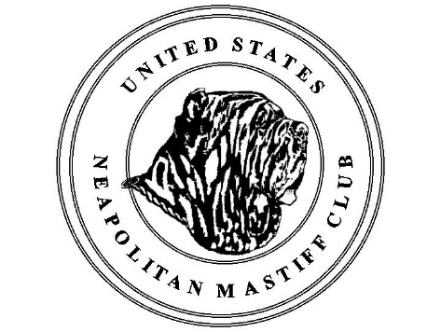
Reproduction Seminar
October 22, 2016 - Saturday
12:00pm – 2:00pm

The USNMC is very pleased to have Dr. Robert Hutchinson as a guest speaker on October 22, 2016 at our National Located at the Roberts Centre, 123 Gano Road, Wilmington, OHIO.
Dr. Hutchinson is the Director of the Center for Canine and Feline Reproduction and Infertility, Inc., a canine and feline frozen semen center established in 1984. He is internationally recognized for his lectures on canine reproduction and neonatology. He has published numerous articles, authored textbook chapters, and produced informational DVDs on dog breeding, whelping and neonatology. He is an adjunct professor for clinical science at the colleges of Veterinary Medicine at The Ohio State University and Purdue University.

Dr. Hutchinson will focus on “why bitches miss” which will include semen, timing of the cycle, inducing, and delaying cycles, etc. This is a 2-hour seminar and will have a short question and answer following the presentation.

Please register in advance as seating is limited.
Advance registration is recommended and is only $30, if seating is still available admittance at the door will be allowed for $40.

Payments can be made through PayPal :
USNMCSTORE@gmail.com (make sure to note that it is for the repro seminar)
If paying through PayPal, please fill out this form and email it to: usnmctreasurermwm@gmail.com

Or you can mail your payment to:
Mike McDonald, USNMC Treasurer, 40 Sam Carroll Rd Lecompte, LA 71364
Print this form and mail it with your payment. Make Checks payable to USNMC
Name: __________________________________
Address: __________________________________
Phone #: __________________________________
Email: _________________________________
Number of people attending: _______________________
Amount paid: _________________________________

